PROJECT REPORT TEMPLATE

1.INTRODUCTION

1.1 OVERVIEW

Uber is a multinational transportation network company that operates a ride-hailing platform. Uber Driver Analysis refers to the Analyzing the number of trips taken by Uber drivers can provide insights into their overall activity and the demand for riders in specific areas.

1.2 PURPOSE

Uber’s data can be analyzed on a daily, weekly, monthly basis to understand the trends and patterns of trip volumes. This analysis can help identify peak hours or days of high demand and optimize driver availability during those times

2.PROBLEM DEFINITION & DESIGH THINKING

2.1 EMPATHY MAP

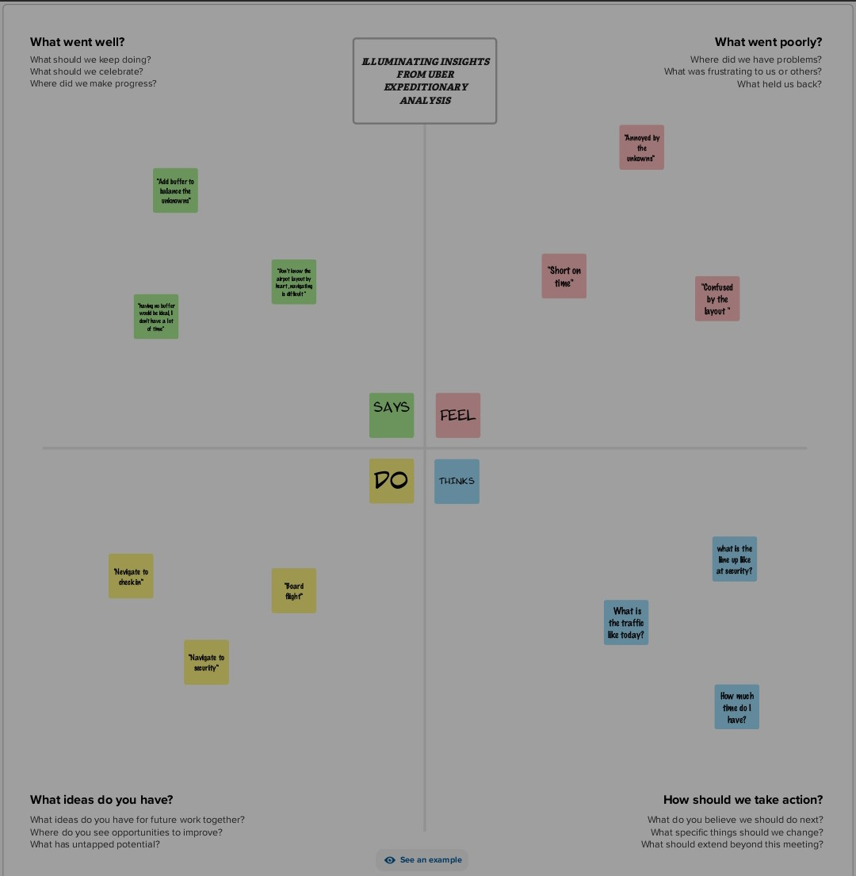

2.2 IDEATION & BRAINSTROMING MAP

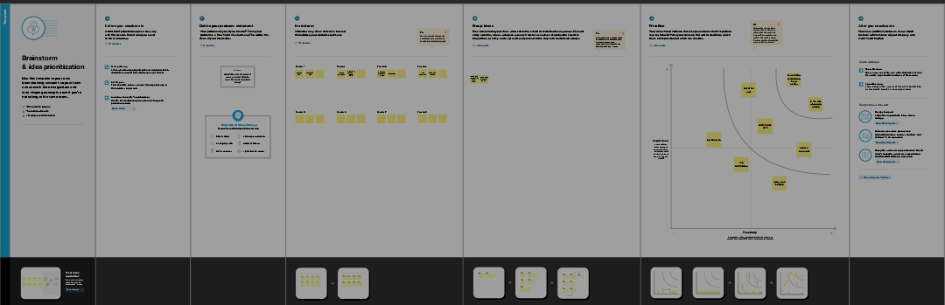

3.RESULT

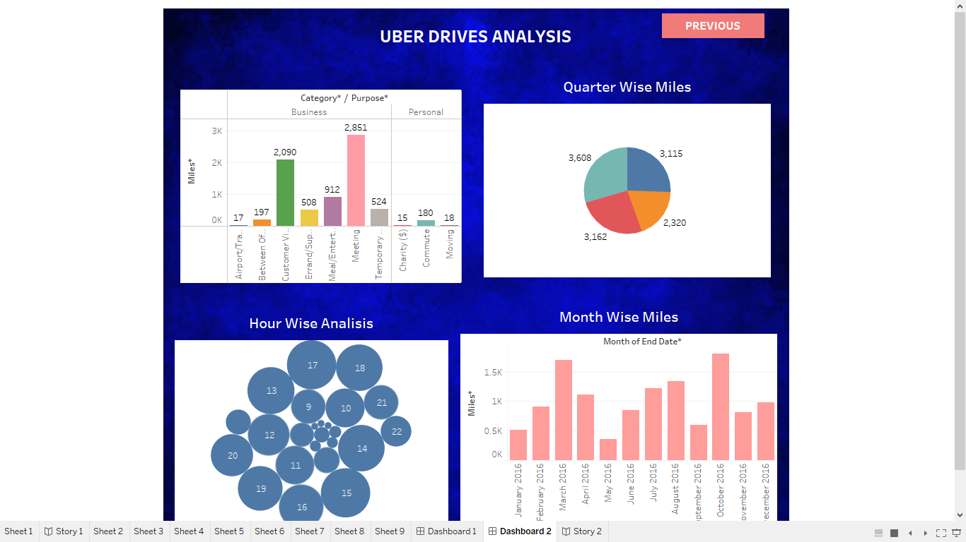

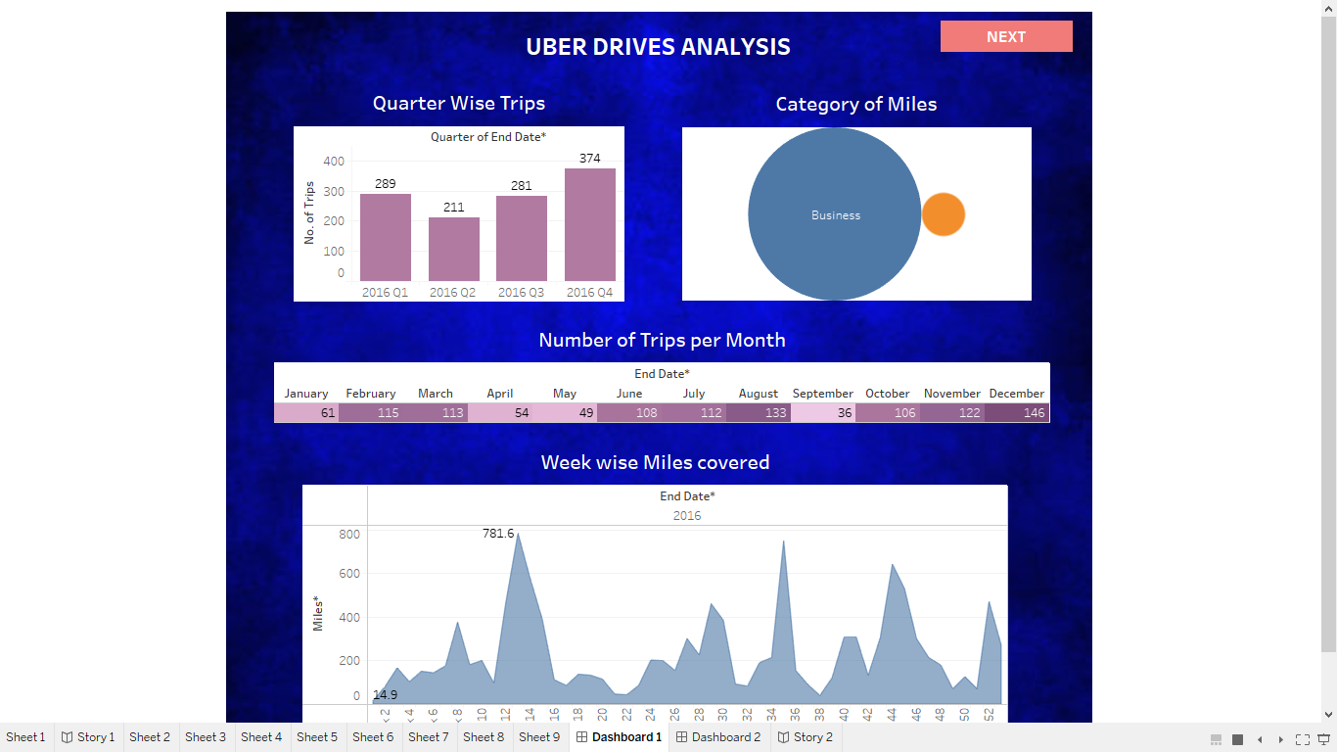

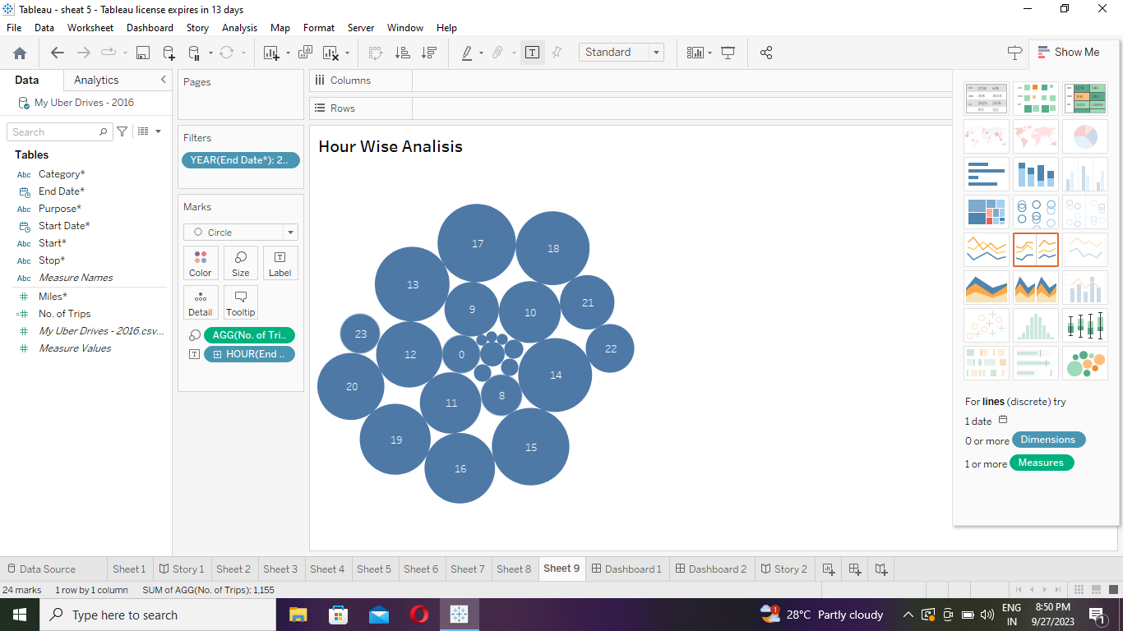

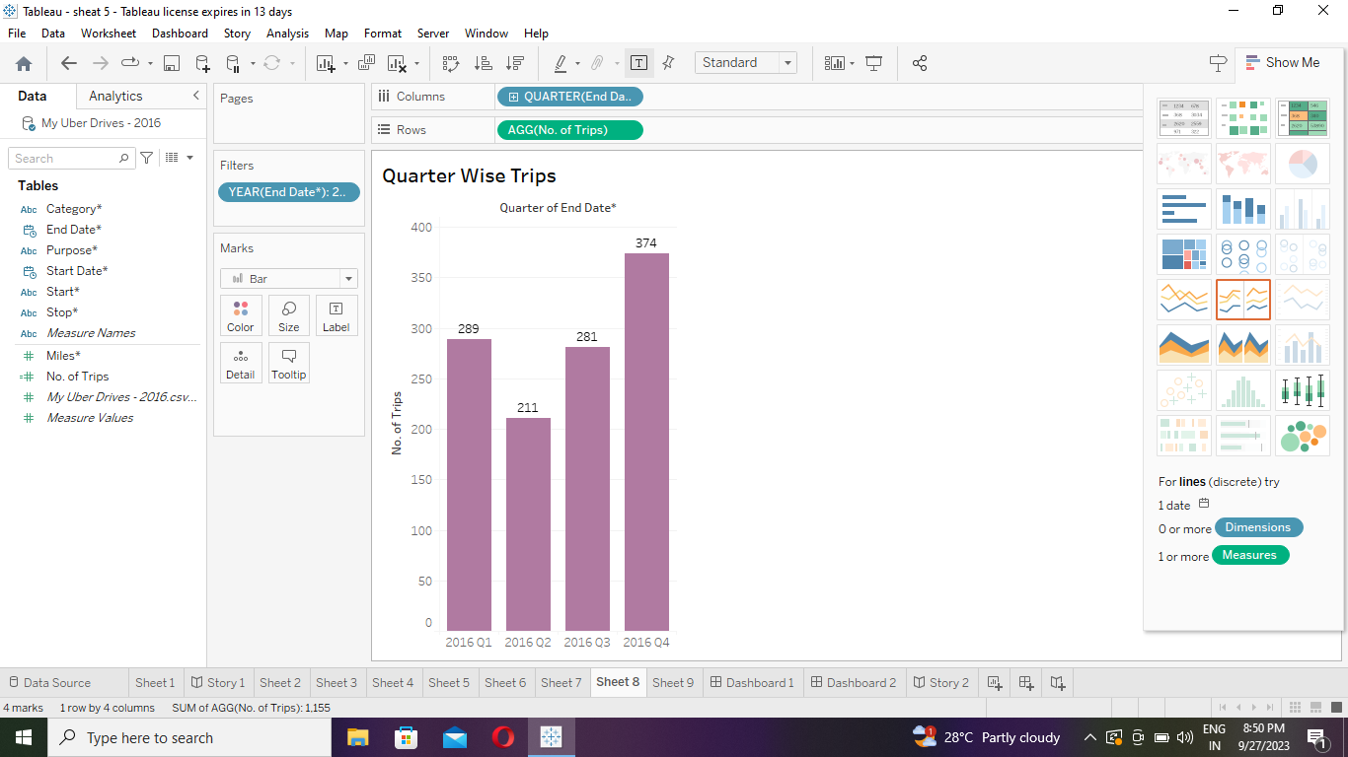

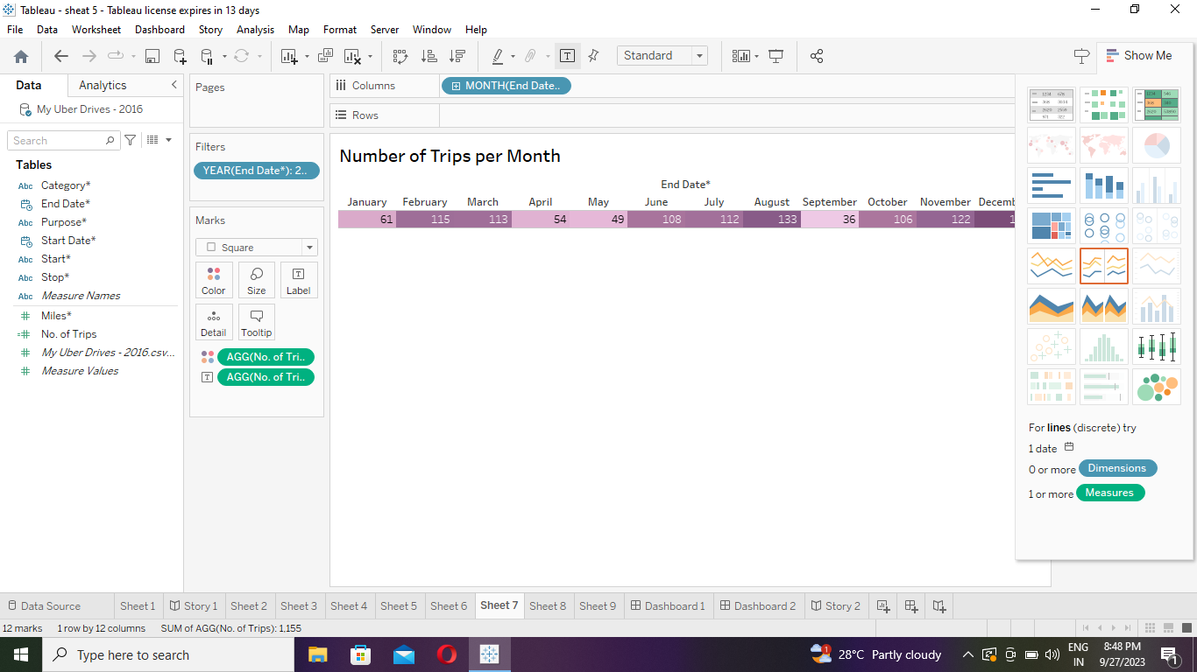

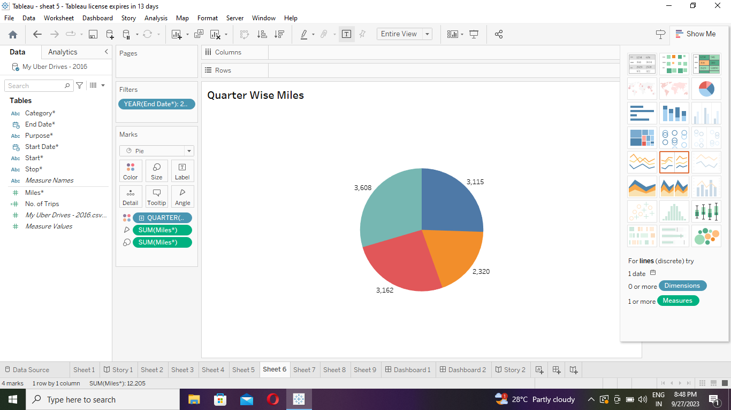

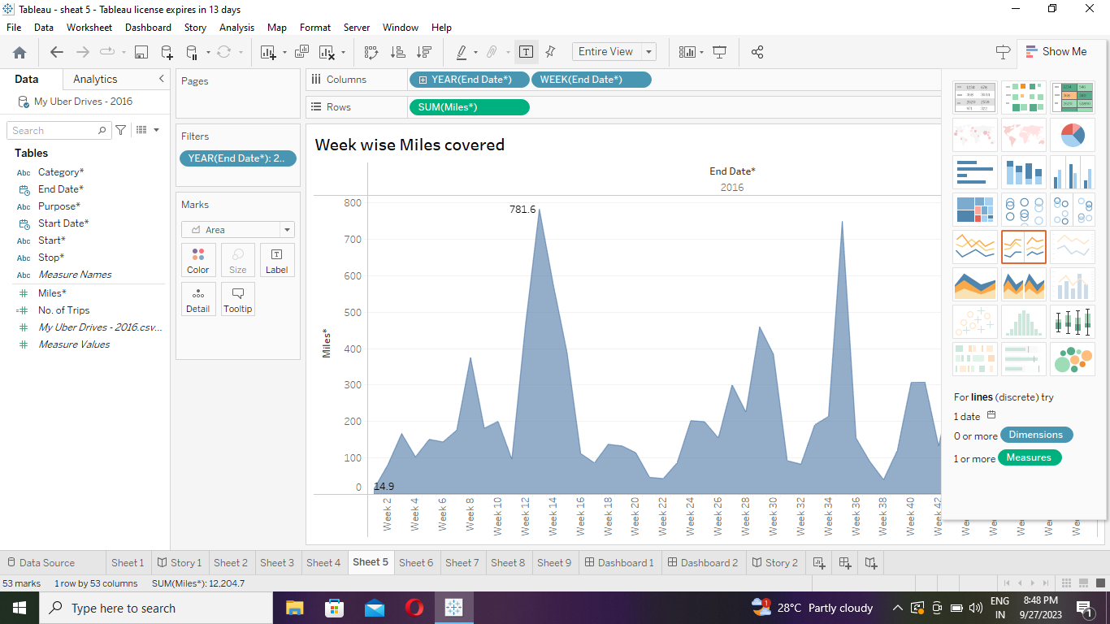

4. ADVANTAGES & DISATVANDAGES

ADVANTAGES

Uber through E-hail has hired drivers easily and fast. Proprietary software in the app locates drivers circling nearby cheapest carpooling luxury wheels. The price is fixed.

DISADVANTAGES

“Surge pricing” or “rush time pricing” is not fixed in uber. It’s a free market principle of raising prices according to supply and demand. This automated system sometimes shows differences in pricing between any two same points. At peak times, the price could be double or more.

5. APPICATIONS

Daily, Weekly or Monthly Analysis: Uber’s data can be analyzed on a daily, weekly, monthly basis to understand the trends and pattens of trip volumes. Trips can be analyzed based on geographic regions or decide where to focus their driving efforts for maximum efficiency and profitability.

6. CONCLUSION

This analysis can help identify peak hours or days of high demand and optimize driver availability during those times.

7. FUTURE SCOPE

The future of Uber Drives Analysis lies in driving efforts, timing efficiency and daily, weekly or monthly trips bases.